Major Ben Richards, (USA, ret.)

60 Minutes, 5 May 2013: http://www.cbsnews.com/video/watch/?id=50146231n

http://www.nytimes.com/2007/07/06/world/middleeast/06military.html?pagewanted=1&_r=2G.I.’s Forge Sunni Tie in Bid to Squeeze Militants

G.I.’s Forge Sunni Tie in Bid to Squeeze Militants

New York Times
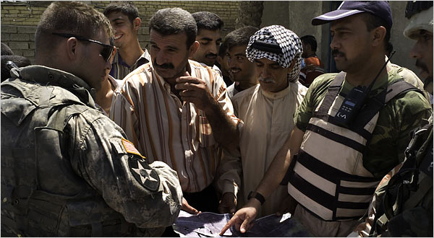
Scott Nelson/World Picture Network, for The New York Times
Capt. Ben Richards, left, discussed the positions of militants recently with residents and the police in the Buhritz sector of Baquba, Iraq.
By MICHAEL R. GORDON
Published: July 6, 2007

http://www.nytimes.com/2012/08/12/opinion/sunday/war-wounds.html?ref=nicholasdkristof

War Wounds By NICHOLAS D. KRISTOF

Published: August 10, 2012
Maj. Ben Richards, who suffered repeated head injuries in Iraq, sums up his future: “It comes to failure.” A car bomb in Iraq in May 2007 left Ben Richards, then a captain, with a severe concussion. A second concussion left him with debilitating injuries. [Note: it took the Army over 5 years to actually diagnose Ben with a TBI. Up to that point, he was disabled with PTSD, so far as he knew. His inability to get better was attributed -- by himself and others -- to his malingering and lack of willingness to work harder.]

*************************

........... some of the rest of the story. The transcript which follows is taken from an interview with MAJ Richards in December 2012, available at:
http://c4tm.org/center/major_ben_richards/
PassWord = HBOT

"I was very fortunate to get the very best care that was available in the US Army. ... The Army determined that I was medically unfit.... There was not an expectation that I would ever be employed again... fully disabled... I couldn't hold a job....the official line was that I wouldn't improve....the goal was to find a new normal....no improvement ....I have been through, as far as I can tell, every type of treatment that is offered by DoD and the VA to help with TBI. I think I have tried every medication for headaches, every medication family group. I have even done Botox injections to my head to try to deal with headaches. I have been through occupational therapy, speech and language therapy, physical therapy, cognitive rehabilitation, psycho therapy and about 4-5 variants... at that point I was introduced to HBOT.... I have seen an amazing improvement. Just orders of magnitude improvement beyond anything....just a huge difference....started working out. For the first time in years I've been able to read a book.... to have hope again....to have more of a future than to just be moving piles of dirt around in the back yard...." [all this after only 40 dives]
****
Just after this interview, Ben was interviewed for 60 Minutes, which segment aired on 5 May 2013. Ben mentioned HBOT several times in the interview, but it was edited out.
****
Further update: Ben has finished 78 dives at Paul Harch's facilities in LA. Ben considers himself so positively transformed by HBOT that he is helping the NBIRR Consortium get help to those we serve.

