http://www.usatoday.com/story/sports/nfl/2013/01/31/nflpa-nfl-concussions/1882079/

NFLPA teams with Harvard for health study, rips NFL
Jim Corbett, USA TODAY Sports10:34 p.m. EST January 31, 2013
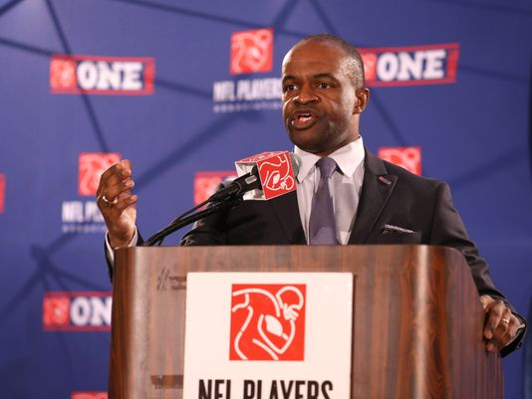
(Photo: Matthew Emmons, USA TODAY Sports)

STORY HIGHLIGHTS
- NFLPA announces $100M partnership grant with Harvard
- NFL plans to add unaffiliated neurological consultants on sidelines next season
SHARE 19CONNECT 13TWEET 5COMMENTEMAILMORE
NEW ORLEANS -- The NFL Players Association announced a 10-year, $100 million partnership grant Thursday with Harvard University to research and treat player injuries and brain and heart illnesses after nearly 80% of players from 32 teams said in a union survey they don't trust team medical staffs.
That distrust stems in part from four teams that required players to sign waivers before receiving injections of the painkiller Toradol.
"We had a disagreement with the NFL with respect to several teams who have forced our players to sign waivers of liability before doctors would give them medical treatment in the form of injecting Toradol," union executive director DeMaurice Smith said. "I cannot think of a more repugnant practice than a doctor forcing a patient to waive liability in order to receive medical care."
COVER STORY: Specter of CTE weighs on Ravens, 49ers
NFL spokesman Greg Aiello said in an e-mail to USA TODAY Sports the union met with league representatives for several hours Jan. 25. "There was no mention of this survey, and the union hasn't told us about it or shown it to us," he wrote.
The union did not say how many of its nearly 2,000 players participated in the survey.
Smith said part of the initiative includes having independent concussion experts on sidelines next season and that the credentials of all team medical staff and team trainers be studied to "see if there's any complaints about malpractice."
In a separate but related announcement Thursday, the NFL said it planned to add unaffiliated neurological consultants to its sideline medical staffs during games next season to bolster efforts to diagnose and treat concussions.
Jeff Pash, NFL executive vice president of labor and general counsel, says, "(The new additions) wouldn't be paid by the club or hired as a club physician."
Richard Ellenbogen, a neurosurgeon and co-chairman of the NFL's head, neck and spine committee, said: "There isn't a league in the world that will have this level of expertise on the field. ... It might be overkill, but at the same time it's just another layer of safety."
The NFL requires that a player must be cleared by the team physician and an independent neurological consultant before he can return to practice or play.
The question remains on how much say the consultant will have about whether a player will be removed from a game because of a suspected concussion.
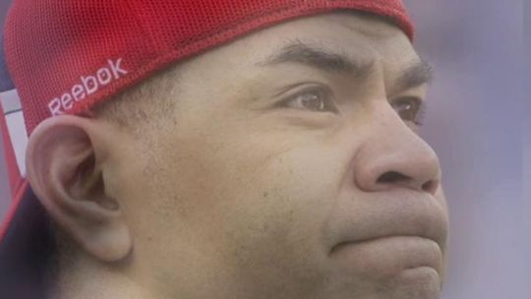
[Web site has video to go with this] http://www.usatoday.com/story/sports/nfl/2013/01/31/nflpa-nfl-concussions/1882079/
"I would think that the diagnosis will ultimately be made by the team doctor, but doctors make diagnoses after consulting with other doctors in many walks of life," Pash said.
But the players want more significant action. Kansas City Chiefs offensive tackle Eric Winston, 29, said he was terrified by something as seemingly mundane as misplacing car keys because it might be an early sign of potential brain disease.
"It's the little stuff — I can't remember people's name at the end of a season," Winston said. "There's talk that they're headed toward being able to identify (degenerative brain disease) in the living. Maybe this research will get us closer toward identification, cure, possible treatments."
Players are putting the onus on the league to step up. "We put $100 million in. They (the NFL) should put $100 million in," Winston said.
Harvard researchers plan to study 1,000 retired players and monitor 100 healthy and unhealthy players.

