Martin R. Hoffmann dies; Army secretary helped guide academy through scandal
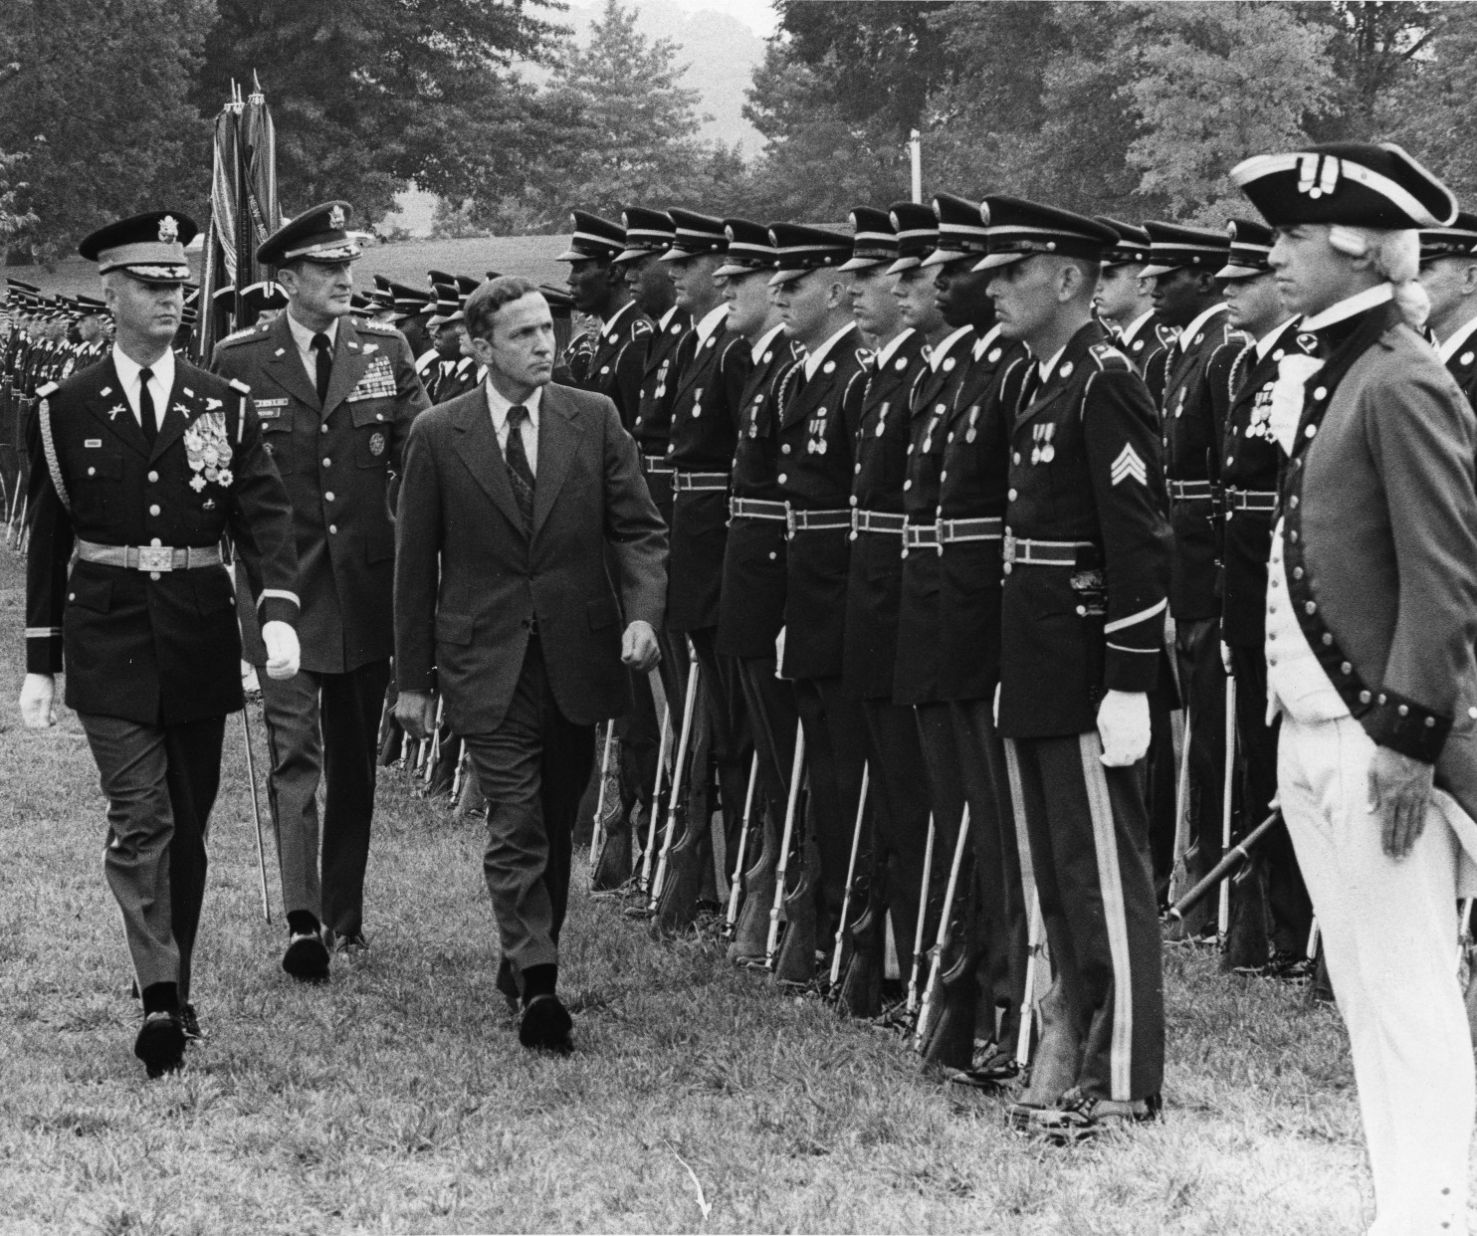
Secretary of the Army Martin R. Hoffmann reviews the troops in 1975. With him is Col. Robert Clark, followed by Gen. Frederick C. Weyand. (Charles del Vecchio/The Washington Post)
By Emily Langer July 22 at 8:45 PM
Martin R. Hoffmann, a lawyer and onetime enlisted soldier who became secretary of the Army and helped guide the service through a high-profile cheating scandal at the West Point military academy in the mid-1970s, died July 14 at a hospital in Warrenton, Va. He was 82.
The cause was complications from cancer, said his wife, Margaret “Muggy” Hoffmann.
Mr. Hoffmann enlisted in the Army in 1954, received his commission after Officer Candidate School and served in the 101st Airborne Division. He later joined the Army Reserve and pursued legal training.
He was working as a lawyer in 1971 when President Richard M. Nixon named James R. Schlesinger chairman of the Atomic Energy Commission. Schlesinger hired Mr. Hoffmann as the commission’s general counsel, or chief legal officer. When Schlesinger became Nixon’s defense secretary in 1973, he took Mr. Hoffmann with him as a special assistant. Mr. Hoffmann, the New York Times once wrote, was Schlesinger’s “gray eminence” at the Pentagon and later became the Defense Department’s general counsel.
Gerald R. Ford, who became president in 1974 after Nixon’s resignation amid the Watergate scandal, named Mr. Hoffmann secretary of the Army. He held the post from August 1975 until shortly after President Jimmy Carter took office in 1977. Mr. Hoffmann served for much of his tenure under Defense Secretary Donald H. Rumsfeld, who had been a classmate at Princeton University.
As the Army’s senior civilian leader, Mr. Hoffmann helped the service continue the transition to an all-volunteer force that began with the abolition of the draft in 1973.
He also helped oversee the development and acquisition of major weapons systems such as Abrams tanks, Bradley infantry fighting vehicles and Apache helicopters, said Raymond F. DuBois, a longtime aide who is now a senior adviser at the Center for Strategic and International Studies.
Mr. Hoffmann’s most prominent role came amid the cheating incident at the U.S. Military Academy at West Point, N.Y.
In 1976, the academy was rocked by allegations that dozens and perhaps hundreds of cadets had cheated on a take-home electrical engineering test. The academy’s storied honor code held that “a cadet will not lie, cheat, or steal nor tolerate those who do.” The only punishment for a violation was expulsion.
The response to the revelations — within the academy, among military leaders and in the general public — was strong and mixed. Supporters of the code argued that it maintained order and ethics and that violators should be punished severely. Others argued that the system was too harsh and that the honor code was applied inconsistently.
Mr. Hoffmann appointed a commission — led by Frank Borman, a former astronaut — to investigate the allegations. The panel found that the military academy bore a degree of institutional responsibility for the cheating because of the “inconsistent” and “at times corrupt” execution of the honor code.
In his final weeks as Army secretary, Mr. Hoffmann approved a recommendation by the panel to readmit cadets who had become entangled in the scandal. He supported a year’s suspension, while the panel had recommended speedier re-enrollment. Mr. Hoffmann also supported changing the honor code to allow greater discretion in disciplinary action, rather than automatic expulsion.
Martin Richard Hoffmann was born April 20, 1932, in Stockbridge, Mass. He was a 1954 English literature graduate of Princeton and a 1961 graduate of the University of Virginia law school. Serving in the Army Reserve, he attained the rank of major.
Early in his legal career, he was an assistant U.S. attorney in Washington, minority counsel on the U.S. House Judiciary Committee and a legal counsel to Sen. Charles H. Percy (R-Ill.).
After his tenure as Army secretary, Mr. Hoffmann went back to legal work.
When Rumsfeld returned to the office of defense secretary in 2001, under President George W. Bush, he asked Mr. Hoffmann to help assemble his senior advisers, DuBois recalled. After the terrorist attacks of Sept. 11, 2001, Mr. Hoffmann assisted Rumsfeld on matters including the war in Afghanistan and the treatment of traumatic brain injury and post-traumatic stress disorder, said DuBois.
Survivors include his wife of 52 years, the former Margaret McCabe, of the District; three children, Cecil “Heidi” Hoffmann Slye of Los Angeles, William Hoffmann of Chennai, India, and Bernhard Hoffmann of Falls Church, Va.; three sisters; and three grandchildren.

