TreatNOW Coalition
June 2026
HBOT Research and Science:
HBOT for TBI/PTSD
Studies Arrayed by the NHMRC Evidence Hierarchy

Based on the Figueroa HBOT Studies Compilation — 30 Studies | 969 Total Subjects

PART I — The Evidence Hierarchy (NHMRC Pyramid)
Evidence-Based Practice (EBP) ranks study designs by rigor. The pyramid below reflects the NHMRC hierarchy — higher tiers indicate stronger methodology and reduced bias. HBOT for TBI/PTSD is supported by evidence spanning every level, with particular strength at Levels 1 and 2.
The pyramid seeks to answer the question: "What is 'the best available evidence'"? The hierarchy of evidence is a core principal of Evidence-Based Practice (EBP) and attempts to address this question. The evidence hierarchy takes a top-down approach to locating the best evidence. First search for a recent well-conducted systematic review. Continue down through available evidence.
EBP hierarchies rank study types based on the rigor (strength and precision) of their research methods. Different hierarchies exist for different question types, and even experts may disagree on the exact rank of information in the evidence hierarchies. The following image represents the hierarchy of evidence provided by the National Health and Medical Research Council (NHMRC), https://canberra.libguides.com/c.php?g=599346&p=4149721.
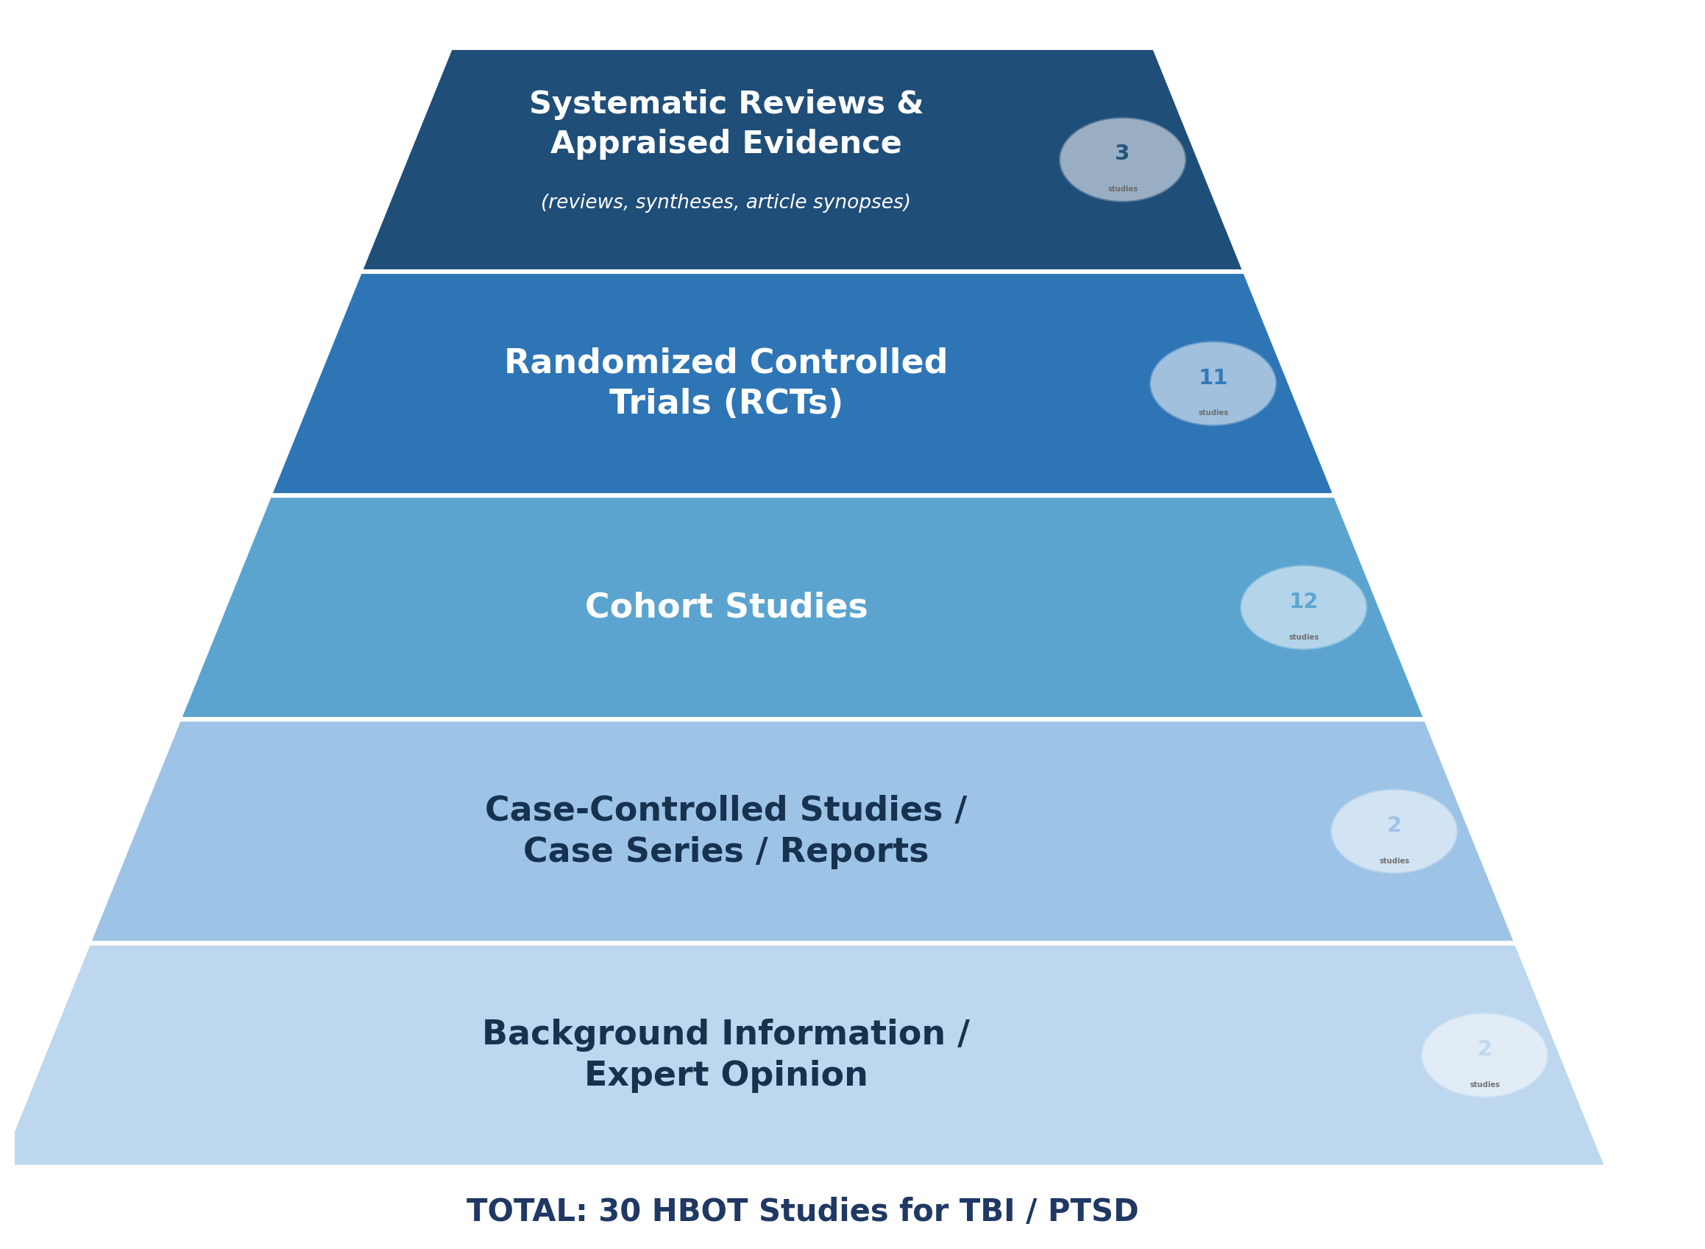
Each tier shows the number of HBOT studies at that evidence level. Tier colors carry through to the level headers in Part II below.

PART II — HBOT Studies Arrayed by Evidence Level
30 studies listed from highest to lowest evidence tier, with full citations, protocol details, and source URLs. Total subjects across all studies: 969.
LEVEL 1 — Systematic Reviews & Appraised Evidence [Highest Evidence]
20. Harch, P.G. (2022). Systematic Review and Dosage Analysis: Hyperbaric Oxygen Therapy Efficacy in Mild Traumatic Brain Injury Persistent Postconcussion Syndrome. Front. Neurol. 13:815056. doi: 10.3389/fneur.2022.815056
Design: Meta-Analysis / Systematic Review
URL: https://www.frontiersin.org/articles/10.3389/fneur.2022.815056/full
22. Doenyas-Barak K, Kutz I, Levi G, Lang E, Beberashvili I, Efrati S. Hyperbaric Oxygen Therapy for Veterans With Treatment-resistant PTSD: A Longitudinal Follow-up Study. Mil Med. 2022 Nov 26:usac360. doi: 10.1093/milmed/usac360.
Design: Meta-Analysis / Longitudinal follow-up
URL: https://pmc.ncbi.nlm.nih.gov/articles/PMC10630921/
25. Andrews SR and Harch PG (2024). Systematic Review and Dosage Analysis: Hyperbaric Oxygen Therapy Efficacy in the Treatment of Posttraumatic Stress Disorder. Front. Neurol. 15:1360311. doi: 10.3389/fneur.2024.1360311
Design: Systematic Review / Meta-Analysis
URL: https://doi.org/10.3389/fneur.2024.1360311

LEVEL 2 — Randomized Controlled Trials (RCTs)
6. Lin JW, Tsai JT, Lee LM, Lin CM, Hung CC, Hung KS, et al. Effect of Hyperbaric Oxygen on Patients with Traumatic Brain Injury. Acta Neurochir Suppl. 2008;101:145–9.
RCT w/ SoC | 2 arms | 1.5 ATA | n=44 | >3 months post-injury
URL: https://www.researchgate.net/publication/51416688_Effect_of_hyperbaric_oxygen_on_patients_with_traumatic_brain_injury
7. Wolf G, Cifu D, Baugh L, Carne W, Profenna L. The Effect of Hyperbaric Oxygen on Symptoms After Mild Traumatic Brain Injury. J Neurotrauma. 2012;29(17):2606–12.
RCT | 2 arms | 1.3 vs 2.4 ATA | 30 dives | 90 min | n=50 | 3–71 months post-injury
URL: https://treatnow.org/knowledgebase/wolf-studyj-neurotrauma-2012-3/
8. Boussi-Gross R, Golan H, Fishlev G, Bechor Y, Volkov O, Bergan J, et al. Hyperbaric Oxygen Therapy Can Improve Post Concussion Syndrome Years After Mild Traumatic Brain Injury — Randomized Prospective Trial. PLoS ONE. 2013;8:1–18.
RCT Crossover | 2 arms | 1.5 ATA | 40 dives | 60 min | n=56 | ~31–35 months post-injury | SPECT imaging
URL: https://journals.plos.org/plosone/article?id=10.1371/journal.pone.0079995
9. Cifu DX, Hart BB, West SL, Walker W, Carne W. The Effect of Hyperbaric Oxygen on Persistent Postconcussion Symptoms. J. Head Trauma Rehabil. 2014;29:11–20.
RCT | 3 arms | 2.0 ATA | 40 dives | 60 min | n=60 | 3–39 months post-injury
URL: https://treatnow.org/knowledgebase/cifu-the_effect_of_hyperbaric_oxygen_on_persistent-99821-1/
10. Miller RS, Weaver LK, Bahraini N, Churchill S, Price RC, Skiba V, et al. Effects of Hyperbaric Oxygen on Symptoms and Quality of Life Among Service Members with Persistent Postconcussion Symptoms: A Randomized Clinical Trial. JAMA Intern. Med. 2015;175:43–52.
RCT w/ SoC | 3 arms | 1.3 & 1.5 ATA | 40 dives | 60 min | n=72 | ~17–27 months post-injury
URL: https://treatnow.org/knowledgebase/jama-miller-study-and-commentary-2/
11. Wolf EG, Baugh LM, Schubert-Kabban CM, Richards MF, Prye J. Cognitive Function in a Traumatic Brain Injury Hyperbaric Oxygen Randomized Trial. Undersea Hyperb Med. 2015;42(4):313–32.
RCT | 2 arms | 1.3 vs 2.4 ATA | 40 dives | 90 min | n=50 | 3–71 months post-injury
URL: https://treatnow.org/knowledgebase/usaf-reappraisal-of-wolf-cifu-study-2015-2/
14. Weaver LK et al. A Randomized Trial of Hyperbaric Oxygen in U.S. Service Members with Post-Concussive Symptoms [BIMA]. Undersea Hyperb Med. 2018;45(2).
RCT | 2 arms | 1.3 & 1.5 ATA | 40 dives | 60 min | n=71 | 25.6 ±16.2 months post-injury
URL: https://www.uhms.org/images/chapters/Pacific/2018/Weaver_BIMA_HBO2_RCT_mTBI_DoD_UHM_45-2_2018.pdf
18. Harch PG, Andrews SR, Rowe CJ, Lischka JR, Townsend MH, Yu Q, Mercante DE. Hyperbaric Oxygen Therapy for Mild Traumatic Brain Injury Persistent Postconcussion Syndrome: A Randomized Controlled Trial. Med Gas Res. 2020;10(1):8–20.
RCT Crossover | 1 arm | 1.5 ATA | 40 dives | 60 min | n=50 | >6 months post-injury
URL: https://treatnow.org/wp-content/uploads/2020/03/Harch-MedGasRes-MAR-2020.pdf
19. Doenyas-Barak K, Catalogna M, Kutz I, Levi G, Hadanny A, Tal S, et al. Hyperbaric Oxygen Therapy Improves Symptoms, Brain's Microstructure and Functionality in Veterans with Treatment-Resistant Post-Traumatic Stress Disorder: A Prospective, Randomized, Controlled Trial. PLoS ONE 17(2): e0264161. doi: 10.1371/journal.pone.0264161
RCT | 1 arm | 2.0 ATA | 60 dives | 90 min | n=29 | MRI/DTI imaging | >4 years post-injury
URL: https://journals.plos.org/plosone/article?id=10.1371/journal.pone.0264161
26. Doenyas-Barak K, Kutz I, Lang E, Assouline A, Hadanny A, Aberg KC, Levi G, Beberashvili I, Mayo A, Efrati S. Hyperbaric Oxygen Therapy for Veterans With Combat-Associated Posttraumatic Stress Disorder: A Randomized, Sham-Controlled Clinical Trial. J Clin Psychiatry 2024;85(4):24m15464. doi: 10.4088/JCP.24m15464
RCT | 2 arms | 1.02 vs 2.0 ATA | 60 dives | 90 min | n=56 | rsfMRI imaging | 12.4 ±7.6 years post-injury
URL: https://doi.org/10.4088/JCP.24m15464
27. Weaver LK, Ziemnik R, Deru K, et al. A Double-Blind Randomized Trial of Hyperbaric Oxygen for Persistent Symptoms After Brain Injury. Sci Rep. 2025;15:885. doi: 10.1038/s41598-025-86631-6
RCT | 2 arms | 1.01 vs 1.5 ATA | 40–80 dives | 60 min | n=47 | >6 months, <10 years post-injury
URL: https://doi.org/10.1038/s41598-025-86631-6

LEVEL 3 — Cohort Studies
1. Hardy P, Johnston KM, De Beaumont L, Montgomery DL, Lecomte JM, Soucy JP, et al. Pilot Case Study of the Therapeutic Potential of Hyperbaric Oxygen Therapy on Chronic Brain Injury. J Neurol Sci. 2007;253(1–2):94–105.
Pre/Post Prospective | 1 arm | 2.0 ATA | 20–60 dives | 60 min | n=1 | SPECT imaging | 12 months post-injury
URL: https://www.jns-journal.com/article/S0022-510X(06)00563-6/fulltext
3. Wright JK, Zant E, Groom K, Schlegel RE, Gilliland K. Case Report: Treatment of Mild Traumatic Brain Injury with Hyperbaric Oxygen. Undersea Hyperb Med. 2009;36(6):391–9.
Pre/Post Prospective | 1 arm | 1.5 ATA | 40 dives | 60 min | n=2 | 8 months post-injury
URL: http://www.echa.net/36-6%20UHM-P391-399.pdf
4. Eovaldi B, Zanetti C. Hyperbaric Oxygen Ameliorates Worsening Signs and Symptoms of Post-Traumatic Stress Disorder. Neuropsychiatr Dis Treat. 2010;6:785–789. doi: 10.2147/NDT.S16071. PMCID: PMC3012456
Pre/Post Prospective | 1 arm | 2.4 ATA | 7 dives | 90 min | n=1 | 4 days post-injury
URL: https://www.ncbi.nlm.nih.gov/pmc/articles/PMC3012456/
5. Stoller KP. Hyperbaric Oxygen Therapy (1.5 ATA) in Treating Sports Related TBI/CTE: Two Case Reports. Med Gas Res. 2011;1(1):17. PMCID: PMC3231948.
Pre/Post Prospective | 1 arm | 1.5 ATA | 40 dives | 60 min | n=2 | SPECT imaging | 3 months–20 years post-injury
URL: https://medicalgasresearch.biomedcentral.com/track/pdf/10.1186/2045-9912-1-17
6. Harch PG, Andrews SR, Fogarty EF, Amen D, Pezzullo JC, Lucarini J, Aubrey C, Taylor DV, Staab PK, Van Meter KW. A Phase I Study of Low-Pressure Hyperbaric Oxygen Therapy for Blast-Induced Post-Concussion Syndrome and Post-Traumatic Stress Disorder. J Neurotrauma. 2012;29(1):168–85.
Pre/Post Prospective | 1 arm | 1.5 ATA | 40 dives | 60 min | n=16 | SPECT imaging | 1.25–4.75 years post-injury
URL: https://bit.ly/4uBqs4i
12. Harch PG, Andrews SR, Fogarty EF, Lucarini J, Van Meter KW. Case Control Study: Hyperbaric Oxygen Treatment of Mild Traumatic Brain Injury Persistent Post-Concussion Syndrome and Post-Traumatic Stress Disorder. Med Gas Res. 2017;7:156–174.
Pre/Post Prospective | 1 arm | 1.5 ATA | 40 dives | 60 min | n=29 | SPECT imaging | 1.25–5.83 years post-injury
URL: https://www.ncbi.nlm.nih.gov/pmc/articles/PMC5674654/
13. Tal S, Hadanny A, Sasson E, Suzin G and Efrati S (2017). Hyperbaric Oxygen Therapy Can Induce Angiogenesis and Regeneration of Nerve Fibers in Traumatic Brain Injury Patients. Front. Hum. Neurosci. 11:508. doi: 10.3389/fnhum.2017.00508
Pre/Post Prospective | 1 arm | 1.5 ATA | 60 dives | 90 min | n=15 | MRI/DCI imaging | 6 months–27 years post-injury
URL: https://www.ncbi.nlm.nih.gov/pmc/articles/PMC5654341/
16. Mozayeni BR, Duncan W, Zant E, Love TL, Beckman RL, Stoller KP. The National Brain Injury, Rescue and Rehabilitation Study — A Multicenter Observational Study of Hyperbaric Oxygen for Mild Traumatic Brain Injury with Post-Concussive Symptoms. Med Gas Res. 2019;9:1–12.
Pre/Post Prospective | 1 arm | 1.5 ATA | 40–82 dives | 60 min | n=32 | 9.5 ±12.7 years post-injury
URL: http://bit.ly/48XUaaH
17. Shytle RD, Eve DJ, Kim S-H, Spiegel A, Sanberg PR, Borlongan CV. Retrospective Case Series of Traumatic Brain Injury and Post-Traumatic Stress Disorder Treated with Hyperbaric Oxygen Therapy. Cell Transplant. 2019;28:885–892.
Pre/Post Prospective | 1 arm | 1.5–1.75 ATA | 20–35 dives | 60 min | n=3 | >1 year post-injury
URL: https://journals.sagepub.com/doi/10.1177/0963689719853232
21. Bested AC et al. A Case Series of 39 United States Veterans with Mild Traumatic Brain Injury Treated with Hyperbaric Oxygen Therapy. Clin Transl Neurosci. 2022;6(3):21. doi: 10.3390/ctn6030021
Pre/Post Prospective | 1 arm | 1.5 ATA | 40 dives | 90 min | n=39 | SPECT imaging | >3–10 years post-injury
URL: https://www.mdpi.com/2514-183X/6/3/21/pdf
23. Bested AC et al. A Case Series of 40 United States Veterans with Mild Traumatic Brain Injury Treated with Hyperbaric Oxygen Therapy. Clin Transl Neurosci. 2026 (In Publication).
Pre/Post Prospective | 1 arm | 1.5 ATA | 40 dives | 90 min | n=40 | SPECT imaging | >3–10 years post-injury
29. Levitt G, Garling H, Stoddard B, Kip KE, Willing AE. (2026). A Prospective, Observational Program Evaluation of Hyperbaric Oxygen Therapy for Veterans with Posttraumatic Stress Disorder. Psychological Trauma: Theory, Research, Practice, and Policy.
Pre/Post Prospective | 1 arm | 1.5 ATA | 60 dives | 60 min | n=50 | >1 year post-injury
URL: https://psycnet.apa.org/fulltext/2027-72202-001.html

LEVEL 4 — Case-Controlled Studies / Case Series / Reports
15. Hadanny A, Abbott S, Suzin G, et al. Effect of Hyperbaric Oxygen Therapy on Chronic Neurocognitive Deficits of Post-Traumatic Brain Injury Patients: Retrospective Analysis. BMJ Open. 2018;8:e023387.
Retrospective | 1.5–2.0 ATA | 40–70 dives | 60–90 min | n=154 | SPECT imaging | 4.6 ±5.8 years post-injury
URL: https://bmjopen.bmj.com/content/bmjopen/8/9/e023387.full.pdf
24. Bin-Alamer O, Abou-Al-Shaar H, Efrati S, Hadanny A, Beckman RL, Elamir M, Sussman E and Maroon JC (2024). Hyperbaric Oxygen Therapy as a Neuromodulatory Technique: A Review of the Recent Evidence. Front. Neurol. 15:1450134. doi: 10.3389/fneur.2024.1450134
Retrospective / Evidence Review
URL: https://bit.ly/3XYn8BV

LEVEL 5 — Background Information / Expert Opinion [Lowest Evidence]
00. Figueroa XA, Wright JK (Col Ret, USAF). Hyperbaric Oxygen: B-Level Evidence in Mild Traumatic Brain Injury Clinical Trials. Neurology. 2016;87:1–7.
Editorial / Commentary — Evidence synthesis
URL: https://treatnow.org/knowledgebase/figueroa-wright-neurology-hbot-evidence/
28. University of South Florida, Tampa, FL. Ongoing RCT for Special Operators and Veterans. ClinicalTrials.gov Identifier: NCT06581003. Anticipated enrollment ~400 subjects. 2.0 ATA | 40 dives | 60 min | fMRI imaging.
Ongoing RCT | 2.0 ATA | 40 dives | 60 min | ~400 subjects | fMRI imaging | >1 year post-injury
URL: https://hbot.usf.edu/

PART III — Figueroa Studies
Dr. Xavier A. Figueroa, PhD is the author or co-author of the following studies included in this compilation.
1. Figueroa XA, Wright JK (Col Ret, USAF). Hyperbaric Oxygen: B-Level Evidence in Mild Traumatic Brain Injury Clinical Trials. Neurology. 2016;87:1–7.
Evidence Level 5 — Editorial / Commentary | Formal analysis of RCT evidence for HBOT in mTBI
URL: https://treatnow.org/knowledgebase/figueroa-wright-neurology-hbot-evidence/
2. Wright JK, Zant E, Groom K, Schlegel RE, Gilliland K. Case Report: Treatment of Mild Traumatic Brain Injury with Hyperbaric Oxygen. Undersea Hyperb Med. 2009;36(6):391–9.
Evidence Level 3 — Pre/Post Prospective | 1.5 ATA | 40 dives | 60 min | n=2 | 8 months post-injury
URL: http://www.echa.net/36-6%20UHM-P391-399.pdf

Abbreviations & Key Terms
ATA: Atmospheres Absolute — unit of pressure used in HBOT protocols
HBOT: Hyperbaric Oxygen Therapy
mTBI: Mild Traumatic Brain Injury
PTSD: Post-Traumatic Stress Disorder
RCT: Randomized Controlled Trial
Retro: Retrospective study design
rsfMRI: Resting State Functional Magnetic Resonance Imaging
SoC: Standard of Care (control arm)
SPECT: Single Photon Emission Computed Tomography (brain imaging)
DTI/DCI: Diffusion Tensor Imaging / Diffuse Correlation Imaging (brain imaging)

TreatNOW Coalition | treatnow.org | June 2026 | For comment and distribution

