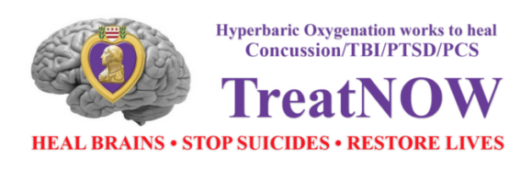
Executive Summary of Why HBOT for NY TBI/PTSD Veterans

We appreciate the efforts and support to migrate NYS as the 15th state to enact and fund Hypbaric Oxygen Therapy (HBOT) treatments for NY TBI/PTSD Veterans. With an estimated 35,716 invisible wounded (TBI/PTSD) NY Veterans there is a very real immediate need to help elminate the suicide epidemic our Veteran community is experiencing both in NYS and across the country.

Veterans within the VA healtch care network have experieniced over 163,000+ suicides since 2002, another 109,000+ opioid deaths, over a quarter million deaths and still counting. We have expended over $3.3 billion on suicide prevention since 2006 without impacting the actual suicide rate trend line. Only 49% of US Veterans are enrolled in VA care meaning 51% are not included in the chart below. The VA does not include reporting of Veteran suicides who served in the National Guard or Reserve components since 2019, significantly under reporting the true suicide epidemic.
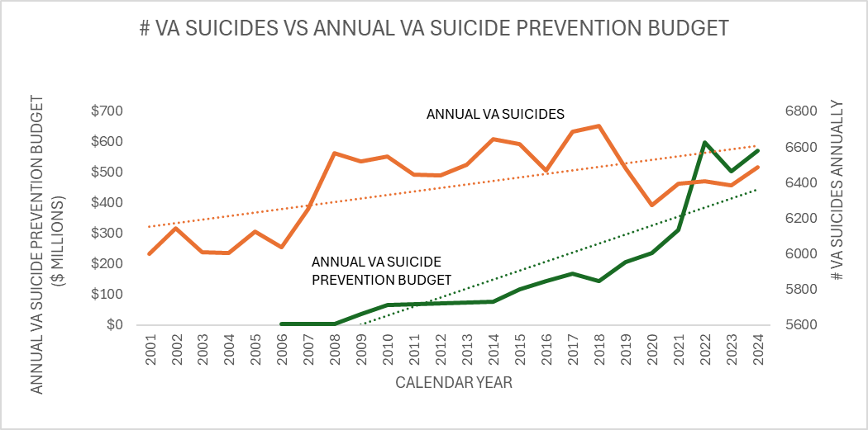

There is nationwide effort to migrate HBOT as a standard of care for all TBI/PTSD invisible wounded Veterans. An estimated 877,450 across the entire U.S. The Twenty-four (24) total HBOT legislative effort states represent an estimated 195 million Americans, 58% of the US population, 10.8 million Veterans, 65% of the total US Veteran population. Over half of all Americans and nearly two-thirds of US Veterans now live in HBOT active (enacted and drafting) states. Converting all yellow states to green will add 77.7 million Americans, 3.7 million Veterans. The 14 states who have enacted HBOT legislation, the cumulative state vote count was 1,955 to 5 in favor of HBOT for TBI/PTSD Veterans. A resounding supportive nationwide state by state vote.

The scientific and medical community has produced 29 clinical trials/studies since 2007 demonstrating safety and efficacy of HBOT for an estimated 1,000 TBI/PTSD Veterans. Two meta-analyses in 2022 and 2024 published documents in the Frontiers of Neurology with sound medical and scientific evidence reflecting on the basis by which HBOT for TBI/PTSD should be adopted across the country.

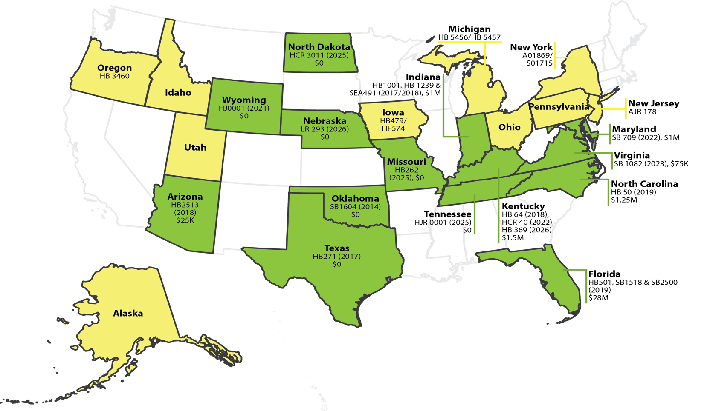

The Israeli Defense Force (IDF) standard of care for TBI/PTSD Veterans is HBOT. Dr. Shai Efrati is the founder and director of the Sagol Center for Hyperbaric Medicine and Research at Shamir Medical Center since 2008. The November 2024 CBS Sunday morning segment highlighted over 350 PTSD patients per day from the Israeli October 7th attack treated with HBOT.

We estimated the 877,450 TBI/PTSD Veterans across America are having an estimated $118.1 billion social economic impact on the US taxpayers, $4.7 trillion over a 40-year lifespan. We can treat and heal all invisible wounded Veterans for ½ of 1 percent of the lifetime cost one time.

We ask for your help in migrating HBOT forward for the NY TBI/PTSD Veterans. The estimated $500K funding for a small observational trial of 10-20 Veterans can be the foundation of a larger population to be treated. The need is real and necessary for our Veterans in NYS. We look forward to working with the Executive and Legislative branches to bring this much needed treatment forward for our NY Veterans as we are already successfully accomplishing across the entire US.

Best Regards,

Joel Goldstein

Joel Goldstein
Executive Director, The BART Foundation, a 501(c)(3) public charity
Do not be daunted by the enormity of the world's grief. Do justly, now. Love mercy, now. Walk humbly, now. You are not obligated to complete the work, but neither are you free to abandon it.

