Israel's Military Rehabilitation Model: A Comparative Analysis of TBI, PTSD, and Suicide Prevention
The invisible physical brain injury and how two military health systems manage brain injuries differently

By Eric Koleda, National Legislative Director, TreatNOW

Over the past two decades, the United States has invested $5.3 billion dollars in suicide prevention programs while continuing to experience persistently high suicide rates among Veterans (see chart Page 4). At the same time, Israel has developed a markedly different military rehabilitation model that emphasizes early recognition of blast-related brain injury, multidisciplinary neurological rehabilitation, objective cognitive assessment, and long-term follow-up. Hyperbaric Oxygen Therapy (HBOT) is one component of the comprehensive rehabilitation strategy. Comparing these two systems may identify opportunities to improve outcomes for American Veterans with Traumatic Brain Injury (TBI) and Post-Traumatic Stress Disorder (PTSD). The current United States Veterans Administration suicide rate is 29.1 per 100,000 as compared to the US civilian rate of 14.9 and the Israeli Defense Force (IDF) of 2.9, a IDF to US ten-fold variance (see chart Page 5).

One reason Israel and the Israeli Defense Force (IDF) have become a global leader in HBOT treatment and research is that they have a concentrated population of combat veterans with blast-related injuries. Israel built an integrated brain injury identification, rehabilitation, and long-term follow-up system in which HBOT is one important component in their centralized healthcare system. There system includes the Ministry of Defense rehabilitation program. Their specialized centers such as the Shamir Medical Center, and government-supported and funded treatment and research programs evaluate Veterans for HBOT treatment of chronic TBI and post-concussion symptoms. The concentration of patients and Veterans within a coordinated rehabilitation system has enabled Israel to conduct some of the most influential HBOT studies in the world for chronic mild TBI post-concussion syndrome. What lessons can the US Department of War (DoW) and Department of Veterans Affairs (VA)learn from the Israeli’s TBI/PTSD treatment program model for identifying, treating, and rehabilitation of Veterans exposed to blast-related brain injury?

This report provides a summary of the differences in the two countries TBI/PTSD assessment and treatment programs. Israel has successfully treated physical TBI/PTSD brain injuries with greater success than the US by administering Hyperbaric Oxygen Therapy (HBOT) to heal the physical brain injuries. Simultaneously, Israel has maintained a low suicide rate with their Veterans to1/10th the rate of U.S.

The IDF Establishes Actual Blast Exposure and TBI Exposed Events

Immediate and real time assessments after exposure to potential brain injury events is a critical initial first step. This chronological documenting of brain injuries is essential. Exposed events may include but not be limited to the following:

💥 IEDs, Shoulder Fired Missiles
💥 RPGs, Rocket attacks, heavy weapon firing
💥 Building collapses, training events
💥 Routine explosive breaching

The difference between the IDF and US is that IDF blast exposure is generally viewed as a potential physical brain injury, even when external wounds are absent.

IDF Immediate Evaluation

The IDF Military Physician, neurologist (when indicated), and combat medic conduct immediate evaluations.
The IDF places more emphasis on documenting the blast pressure exposure and cognitive symptoms, balance, memory, headaches, and sleep rather than relying on psychiatric symptoms.

In the US it may be months or years before Veterans are properly diagnosed with TBIs. The current DoW system may penalize Veterans from acknowledging a TBI as an “unfit for duty” injury jeopardizing military careers. This cascades into Veterans non-sharing of medical symptoms and related cognitive decline until late medical intervention and discharge. Routinely, treatment is a cascade of off-label pharmacology prescribed for each of the varying associated symptoms. Nearly all these drugs are black box labeled for increased suicidality and implicated in the 29.1 US suicide rate. This occurs while the US 1990 Textbook of Military Medicine directs that Veterans with evidence of external closed head injury should be administered Hyperbaric Oxygen Therapy (HBOT).

IDF Comprehensive Assessment

Rather than asking "Does this Veteran have PTSD?" the process is closer to asking "What injuries did this blast create?" The IDF includes mild TBI (mTBI), PTSD, hearing injury (Tinnitus), vestibular injury, vision dysfunction, and cognitive impairment. Many patients receive multiple diagnoses rather than a single PTSD label.

The US routinely has one MD conduct an initial TBI/PTSD assessment and one diagnosis with potentially multiple cognitive impairments associated with the one diagnosis. Advanced brain imaging to detect potential TBIs is not routinely required.

IDF Integrated Treatment Plan

The IDF treatment plan may include combinations of neurological and psychological therapies, physical rehabilitation, vestibular rehabilitation, vision rehabilitation, occupational therapy and HBOT.

The US treatment plan starts with a standard diagnosis of PTSD for the vast majority of blast exposed Veterans and proceeds to symptom management by Psychiatric support and medication first, followed by behavioral therapy.

IDF Hyperbaric Oxygen Therapy

Unlike the U.S. VA system, Israel has conducted multiple clinical studies and uses HBOT in civilian and military settings for chronic mild TBI persistent post-concussion cases and PTSD. A November 10, 2024, CBS News broadcast discusses how HBOT heals PTSD with HBOT for victims of the October 7th attack. Large multi-chambers above and underground chambers below, the first of its kind, The Tel Hashomer HBOT Center are treating upwards of 350 Veterans/patients per day with chronic TBI and PTSD. HBOT is viewed as one component of rehabilitation, not necessarily as a stand-alone therapy, and is integrated into a broader rehabilitation program.

Neither the VA nor DoW have adopted or deployed HBOT treatments as a standard of care for TBI/PTSD Veterans in either the civilian or military sectors. Fourteen states have enacted HBOT legislation and 7 of these states have approved and funded $33 million for HBOT treatments of Veterans with chronic TBI or PTSD. To date, over 12,500+ Veterans with chronic TBI or PTSD have been successfully treated since 2008 across the entire U.S. In Kentucky, the template for America, incorporation of six hospitals administering HBOT treatments statewide is key to being able to treat the number of US Veterans who require HBOT treatments.

Why Israel’s Rehabilitation Model Produces Different Outcomes

The IDF treatment program consists of definitive initial TBI assessments, repetitive objective cognitive and functional testing, and HBOT treatments. It results in return to duty or civilian life with long-term monitoring with governmental support and funding.

The US treatment program consists of repetitive psychiatry appointment for medication management of symptoms along with individual and group psychological therapy. Pharmacologic therapy is characterized by frequent undesirable medication side effects, including increased suicidality. In the TreatNOW network of approximately a hundred Veterans have provided video testimonials on the safety and efficacy of HBOT for mTBI and PTSD.

US AND ISRAEL TBI/PTSD SUICIDE MANAGEMENT COMPARISON
United States (Current Process) | Israel / IDF Approach
Average US suicide rate 29.1 per 100,000 | Israeli/IDF suicide rate 2.9 per 100,000
Blast often undocumented | Blast documented as potential brain injury
PTSD diagnosis frequently predominates | TBI and PTSD evaluated together
Symptom management emphasized | Injury identification emphasized
Off-label medications routinely prescribed | Multidisciplinary rehabilitation emphasized
HBOT unavailable through routine VA/DoD care for TBI/PTSD | HBOT funded and prescribed in rehabilitation programs
Separate specialty medical silos | Greater integration across specialties
Brain injury may remain undiagnosed | Physical brain injury actively investigated
VA/DoD does NOT cover HBOT for chronic TBI/PTSD | Ministry of Defense Rehabilitation Department funds HBOT for combat Veterans
29 private and government clinical trials/studies since 2007 demonstrating safety and efficacy | Extensive government supported HBOT research in chronic TBI/PTSD
Over 1,200+ Hospitals and 300+ Clinics with HBOT treatment facilities | Approximately 20-25 HBOT treatment facilities
14-state enacted HBOT laws, 7 states funded $33 million in HBOT treatments | HBOT treatment federally supported and funded
Approximately 9 million in VA Healthcare | Approximately 90,000 Veterans in disability by 2026
Estimated 877,450 with TBI/PTSD | Estimated 10,000-25,000 with TBI/PTSD

IDF SUICIDE REDUCTION STRENGTHS
Israel's military suicide rate is 2.9 versus 29.1 for the reported rate among U.S. Veterans. Multiple structural differences exist between the two systems, including earlier neurological evaluation, integrated rehabilitation, routine objective outcome testing, coordinated long-term follow-up, and broader incorporation of HBOT treatment into the IDF rehabilitation program. The fact the US system is producing ten times the number of suicides warrants an immediate assessment to determine which Israeli practices should be adopted and integrated to improve outcomes within the U.S. military and VA healthcare systems

Every Israeli citizen is covered by the country's universal healthcare system. HBOT is included in the national health benefits package ("Health Basket") for specific medical conditions. Israeli HMOs (Clalit, Maccabi, Meuhedet, and Leumit) pay for HBOT for these specific medical conditions which are similar to the US FDA medical condition list except for “other accepted hyperbaric indications defined by the Ministry of Health.” “These other accepted hyperbaric indications” include combat related TBIs, chronic post-concussion syndrome, and treatment resistant PTSD. IDF Veterans receive HBOT treatments and are paid for through the Israeli Ministry of Defense Rehabilitation Department.
In summary, IDF's approach of treating mTBI/PTSD injuries with HBOT is working. They are treating their Veterans and allowing them to return to their pre-military service life on a much broader scale than the United States. Their Veteran suicide rate is 10-fold lower than that of the US. HBOT has been proven to be safe and effective, is standard of care, and a major part of IDF's success.
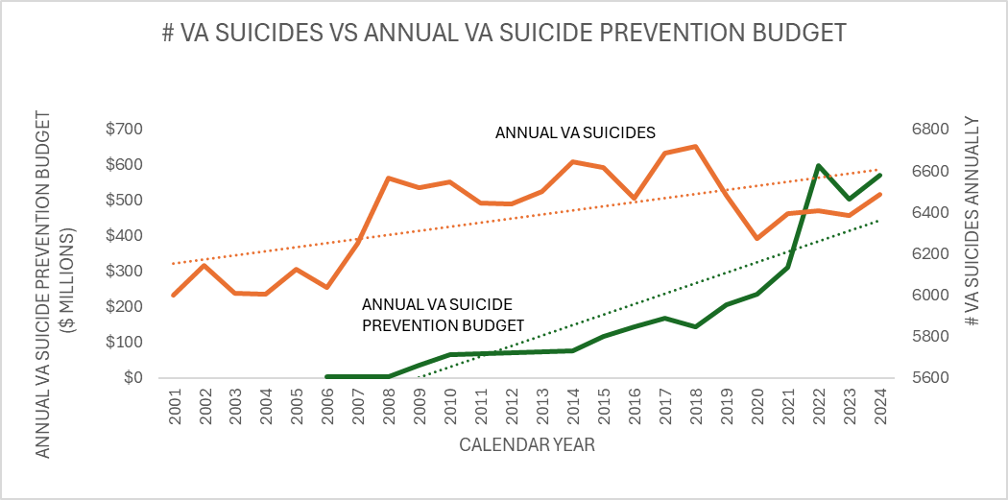
- Palliating TBI/PTSD Symptoms with off-label drugs has contributed to over 163,000 Veteran Suicides with 109,000+ opioid deaths. There are no FDA approved drugs for TBI, and only two for PTSD, Zoloft and Paxil
- The VA introduced an opioid epidemic from 2006 to 2014 with over 847 million opioid pills (DEA.gov) distributed by 4Q2012. This led to Opioid Use Disorder (OUD) in over 679,000 VA Veterans.
- The VA, DoW, and other governmental agencies have spent over $5.3 billion on suicide prevention with only a transient decrease in suicides with an upward trend line for both suicides and expenditures.

US VETERANS’ VS US CIVILLIANS VS ISRAELI DEFENSE FORCE (IDF) SUICIDES RATE PER 100,000
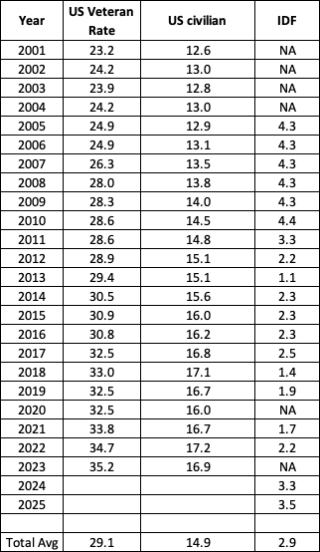
Note 1: US Veteran and civilian rates from the mentalhealth.va.gov website, 2025 National Veteran Suicide Prevention Annual Report, Part 2: Report Findings, Page 13, March 2026
Note 2: The IDF rates were based on total reported suicides per year divided by 635,000 total Veterans times 100,000
Note 3: The IDF 2001-2004 and 2023 reported suicides were not available. The 2005-2009 average reported suicides were 26-28 and we used 27 suicides as the average for calculation on rate per 100,000.
Note 4: There is a significant variance in the total number of IDF Veteran population (635,000) versus the US (19.5M) which could impact statistical rates per 100,000. IDF had 19 reported years versus 23 for the VA.
Note 5: We did not identify a standard IDF annual report on suicides but instead used what was released and published in the news media for each of the reporting years.

