PTSD and TBI: A Primer
Oct 7, 2026 · @Rob

Why these two belong together
Traumatic brain injury (TBI) is a physical injury to the brain; post-traumatic stress disorder (PTSD) is a psychiatric disorder that follows a terrifying event. They are different conditions, but they often start with the same moment: a blast, a crash, an assault. That shared origin is why they so often travel together, and why they are so hard to pull apart.
The scale is large. The Department of Defense counts 535,544 service members with a first TBI diagnosis between 2000 and the end of 2025, about 83% of them mild (concussion). A national survey of U.S. veterans fielded in 2025–2026 found lifetime PTSD in 14.4% and current PTSD in 7.3%, the highest rates recorded in that study series since 2011.
Neither condition is confined to the military. Most TBIs happen in falls, car crashes, sports and violence, and PTSD follows sexual assault, intimate partner violence, disasters and first-responder work as readily as combat. Both are sometimes called "invisible wounds": they rarely show on the outside, and often not on a standard scan.
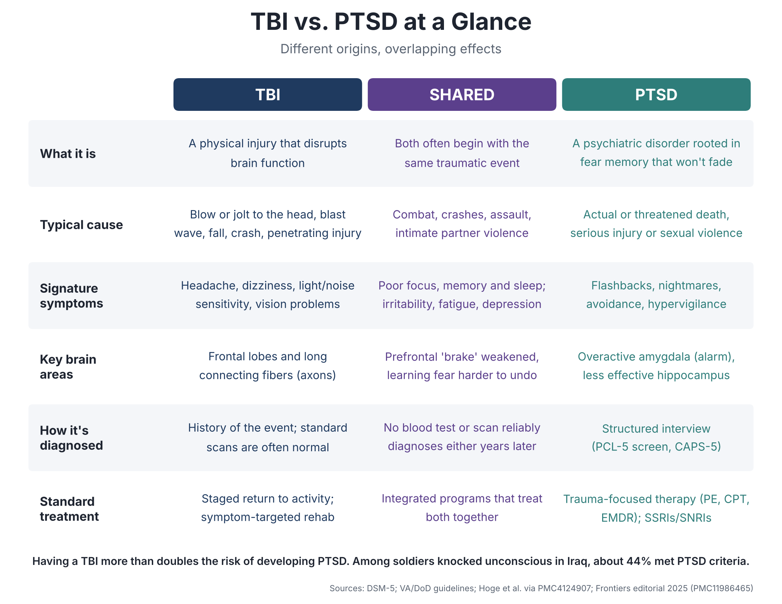
Figure 1. TBI and PTSD at a glance: different origins, overlapping effects.

What TBI is
A TBI is a disruption of normal brain function caused by an external force: a blow or jolt to the head, rapid acceleration and deceleration, a penetrating object, or a blast wave. The word "traumatic" here means physical trauma, not psychological trauma.
Severity is graded by what happens in the hours after injury, not by how bad the event looked. The VA/DoD criteria most clinicians use:
Severity | Loss of consciousness | Altered consciousness | Memory loss after injury | Standard imaging
Mild (concussion) | 0–30 minutes | Up to 24 hours | Up to 1 day | Normal
Moderate | 30 minutes–24 hours | More than 24 hours | 1–7 days | Normal or abnormal
Severe | More than 24 hours | More than 24 hours | More than 7 days | Normal or abnormal
The damage happens in two waves. The primary injury is mechanical: neurons and their long connecting fibers (axons) are stretched and sheared, and small blood vessels tear. The secondary injury unfolds over days to weeks: inflammation, swelling, disrupted blood flow, oxygen shortfall in injured tissue, and an energy crisis inside cells. Much of the lasting harm, and most of the treatment opportunity, lives in this second wave.
Most people with a single mild TBI recover within weeks; DoD reports most service members return to full duty within 10 to 14 days. But a meaningful minority do not. Persistent headaches, poor sleep, dizziness, slowed thinking, irritability and light or noise sensitivity can last months or years, especially after repeated injuries. Blast exposure is a distinct concern for the military: troops can absorb hundreds of low-level blasts from their own weapons in training, with effects researchers are still mapping.

What PTSD is
PTSD is a disorder of fear memory: the brain keeps responding to a past threat as if it were still present. It can develop after exposure to actual or threatened death, serious injury or sexual violence, whether experienced directly, witnessed, or encountered repeatedly on the job.
The psychiatric manual (DSM-5) requires symptoms in four clusters lasting more than a month and causing real impairment:
- Intrusion: unwanted memories, nightmares, flashbacks, intense reactions to reminders.
- Avoidance: steering clear of people, places, thoughts or conversations linked to the event.
- Negative changes in thinking and mood: guilt, shame, detachment, loss of interest, gaps in memory of the event.
- Arousal and reactivity: hypervigilance, exaggerated startle, irritability, poor concentration, insomnia, reckless behavior.
Most people exposed to trauma do not develop PTSD; early distress usually fades. Risk rises with the severity and type of trauma, prior trauma, lack of social support, and ongoing stress afterward. In the 2025–2026 veterans survey, interpersonal violence carried the highest risk: about half of those whose worst trauma was adult sexual assault had developed PTSD, compared with a third for military-related trauma (source).
Untreated, PTSD tends to be chronic. It travels with depression, substance use, chronic pain and elevated suicide risk.

Where they meet
Having a TBI more than doubles the risk of developing PTSD, and the more serious the head injury, the higher the risk. PTSD often occurs without any TBI, but the reverse link is strong (Frontiers editorial, 2025).
The landmark evidence came from soldiers returning from Iraq. Among those who had been knocked unconscious, about 44% met PTSD criteria, versus 27% of those who were dazed, 16% with other injuries, and 9% who were uninjured (review, PMC4124907). That gradient held after accounting for how much combat each soldier saw.
This surprised researchers. It was long assumed that losing consciousness would protect against PTSD, since you cannot be haunted by a memory you never formed. It turns out fear can be learned below the level of conscious memory, and people reconstruct what happened from others' accounts and from fragments (NCBI Bookshelf chapter).
The practical problem is that the two conditions look alike, as Figure 2 shows:
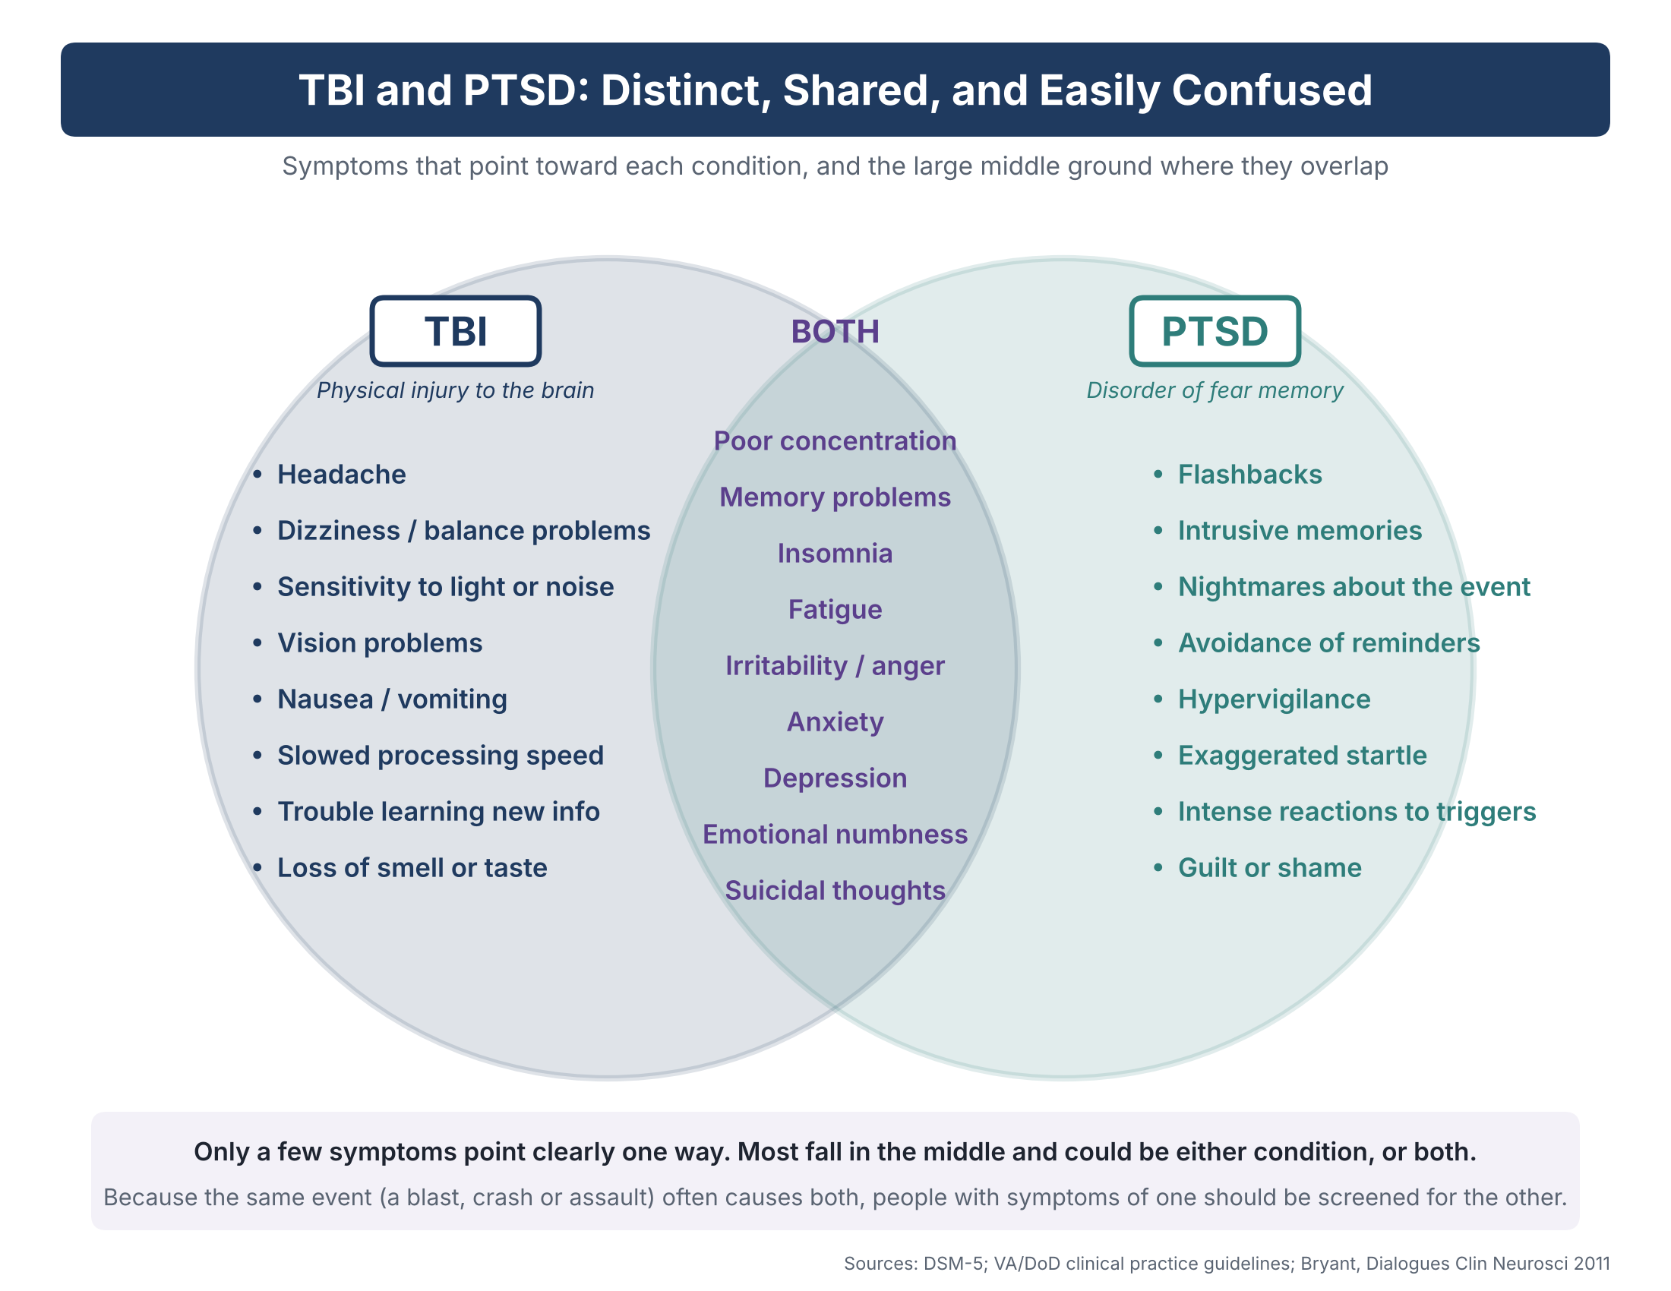
Figure 2. Symptoms that point toward TBI, toward PTSD, or could be either.
Only a few symptoms point clearly one way: headache, dizziness and sensory sensitivity toward TBI; flashbacks, avoidance and hypervigilance toward PTSD. Everything in the middle could be either, or both.

The biology: why one makes the other worse
TBI and PTSD strain the same brain circuit, which is the leading explanation for why one raises the risk of the other. Three regions matter most:
- Amygdala: the alarm. It detects threat and triggers the fight-or-flight response. In PTSD it is overactive.
- Prefrontal cortex: the brake. It judges whether a threat is real and calms the alarm when it is not. In PTSD it is underactive.
- Hippocampus: the context keeper. It tags memories with time and place, so that a past danger is filed as past. In PTSD it often works less well.
The frontal lobes and the long fibers that connect them to deeper regions are exactly what acceleration, deceleration and blast injuries tend to damage. A concussion can therefore weaken the brake at the moment the alarm is firing hardest. The result is a brain that learns fear easily and unlearns it poorly, which is the core of PTSD.
Other shared pathways add to this:
- Inflammation: both conditions show raised inflammatory markers, and brain injury can leave inflammation smoldering for months.
- Stress hormones: TBI can disrupt the pituitary and the hormonal stress axis that PTSD already dysregulates.
- Sleep: both wreck sleep, and poor sleep impairs both brain repair and the processing of fear memories.
- Blood flow and energy: injured tissue can have poor blood supply and oxygen delivery for long periods, a target for several emerging treatments.
The causal arrow also runs the other way. A leading review argues that much of the lingering impairment after mild TBI is driven by stress reactions rather than by the injury itself (Bryant, 2011). Others argue that PTSD itself involves measurable physical changes in the brain. Both camps agree on the practical point: in a person with both, neither can be treated in isolation.

Diagnosis: why it is hard
There is no blood test or scan that diagnoses either condition in a typical patient, so both rest largely on history and self-report.
- Mild TBI is often never recorded. Many concussions happen in the field or at home and are shrugged off. Months later, a clinician must reconstruct whether a brain injury occurred from the person's memory of an event that may itself have disrupted memory.
- Standard imaging is usually normal. CT and routine MRI catch bleeding and fractures, not the microscopic fiber damage of concussion. Advanced methods such as diffusion tensor imaging can show group differences in research but are not yet reliable for diagnosing an individual. FDA-cleared blood tests (GFAP and UCH-L1) help emergency doctors decide whether a CT is needed in the first hours, not years later.
- PTSD is diagnosed by structured interview. Clinicians use screens such as the PCL-5 and interviews such as the CAPS-5. These depend on the person's willingness to disclose, which stigma and career concerns can suppress.
- Overlap blurs attribution. As the table above shows, most symptoms fit either condition. Clinicians often cannot say how much of a patient's poor concentration comes from injury and how much from stress.
The result is underdiagnosis in both directions. PTSD after brain injury frequently goes unrecognized (Brain Injury Association of Virginia), and old concussions are missed in people being treated for PTSD. Attribution also has money attached: the VA rates TBI and PTSD on separate scales and will not compensate the same symptom twice.

Treatment landscape
Both conditions are treatable, and the standard PTSD therapies work in people who also have mild TBI. The harder cases are the ones that stall despite standard care.
For PTSD, the VA/DoD guidelines put trauma-focused talk therapy first:
- Prolonged Exposure: gradually and safely revisiting the memory and avoided situations until they lose their power.
- Cognitive Processing Therapy: identifying and revising the beliefs the trauma left behind, such as guilt or a sense of permanent danger.
- EMDR: processing the memory while following a side-to-side stimulus.
- Medication: sertraline, paroxetine and venlafaxine are the recommended options, generally less effective than the therapies above.
Many patients improve substantially, but dropout is high and a large share still have symptoms after a full course.
For TBI, care is mostly symptom-by-symptom: a staged return to activity after concussion, then targeted rehabilitation for headache, dizziness, vision, sleep and thinking problems. There is no approved drug that repairs the injured brain.
For both together, the trend is toward integrated, intensive programs. Examples include the National Intrepid Center of Excellence's multi-week outpatient program and "massed" formats that deliver weeks of therapy in days, often combined with physical rehabilitation and family involvement (Frontiers editorial). Cognitive problems from TBI can make standard therapy harder to complete, so programs adapt with shorter sessions, written aids and repetition.
Emerging approaches aim at the biology rather than the symptoms. None is yet standard care:
- Transcranial magnetic stimulation (TMS): magnetic pulses to boost underactive frontal regions; several sham-controlled trials in PTSD with TBI show benefit (review).
- Stellate ganglion block: an injection in the neck that damps the fight-or-flight nerve supply; mixed trial results.
- Psychedelic-assisted therapy: MDMA showed large effects in trials, but the FDA declined approval in 2024 over study-design concerns; research continues, including on psilocybin and ibogaine.
- Hyperbaric oxygen therapy (HBOT): breathing pure oxygen under pressure to restore oxygen delivery and promote repair in injured tissue. Randomized trials from Israel and the U.S. report improvements in post-concussion and PTSD symptoms. Earlier military trials found that both the treatment and the "sham" groups improved, a result proponents attribute to a sham that was itself mildly pressurized. VA and DoD have not adopted it as standard care.

Why it matters, and what is still unknown
The combination is more dangerous than either condition alone. People with both TBI and PTSD have more severe PTSD symptoms, and the pairing, often with depression, raises the risk of suicidal thinking, attempts and death (PMC10456657). It also costs jobs, marriages and military readiness.
The populations are wider than the headlines. Survivors of intimate partner violence often sustain repeated, unreported blows to the head alongside severe psychological trauma, yet are rarely screened for brain injury. Police, firefighters, contact-sport athletes and breachers who absorb repeated blasts face similar overlaps.
The biggest open questions:
- Measurement: can a blood test, scan or brain-wave signature reliably show mild TBI or PTSD in an individual, years after the event?
- Mechanism: how much of persistent impairment is injured tissue, and how much is the stress response? The answer shapes which treatments make sense.
- Repeated exposure: what do hundreds of low-level blasts or hits do over a career, and is there a safe threshold?
- Treatment for non-responders: what works for the large group that does not recover with standard therapy, and how should emerging biological treatments be tested fairly?
- Long-term course: how do these injuries interact with aging, dementia risk and chronic traumatic encephalopathy (CTE)?
For a policymaker, the takeaway is simple. TBI and PTSD should be screened for together, treated together, and researched together, because in the people who carry both, they are not separate problems.

Key sources
- DOD TBI Worldwide Numbers, 2000–2025 Q4 — Traumatic Brain Injury Center of Excellence
- National Trends in PTSD Among US Military Veterans: 2025–2026 National Health and Resilience in Veterans Study — Journal of Clinical Psychiatry, May 2026
- Post-traumatic stress disorder vs traumatic brain injury — Bryant, Dialogues in Clinical Neuroscience, 2011
- Traumatic brain injury and PTSD: from neurobiology to treatment — Frontiers editorial, 2025
- PTSD, substance use and TBI in returning soldiers — review including Iraq-era prevalence data
- PTSD and TBI chapter — in Laskowitz and Grant (eds.), Translational Research in Traumatic Brain Injury, NCBI Bookshelf
- Severity of PTSD with and without comorbid TBI
- rTMS in PTSD and PTSD with TBI: a review
- Understanding TBI and PTSD — Brain Injury Association of Virginia
Severity criteria, DSM-5 symptom clusters and guideline treatment recommendations follow the VA/DoD clinical practice guidelines and DSM-5, summarized from general knowledge rather than a page opened for this primer.

